# UNIT 5 SOME BASIC TRIGONOMETRY

## 5.1 The Basic Trigonometric Functions

### Right Triangle Trigonometry

There are six trigonometric functions associated with right triangles. Since our focus is on the mathematics of games, we will concentrate on only three of them, the sine function, the cosine function, and the tangent function.

The sine function is useful for producing the vertical motion of an object and the cosine function for producing the horizontal motion.

The figures just below show right triangles with angle , and sides opposite angle adjacent to angle , and the hypotenuse of the triangle

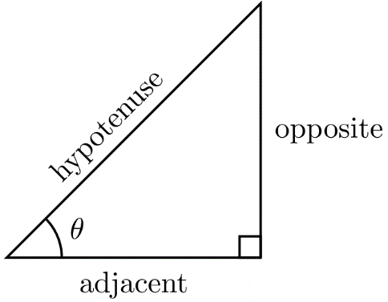 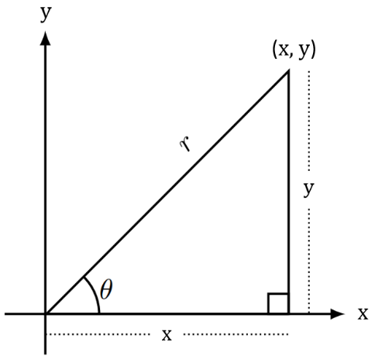

The angle has two measures associated with it:

1. Its degree measure, which we can label , and
2. Its trigonometric measure.

A trigonometric measure of an angle is a ratio (quotient) of two of the sides of the triangle.

We will discuss all three of these ratios, the sine, the cosine, and the tangent of an angle.

### The Sine of an Angle

In words: In a right triangle, the *sine* of angle is the ratio of the length of the side opposite to the length of the hypotenuse. We abbreviate the phrase “the *sine* of angle ” with .

Then, . That is .

### The Cosine of an Angle

In words: In a right triangle, the *cosine* of angle is the ratio of the length of the side adjacent to to the length of the hypotenuse. We abbreviate the phrase “the *cosine* of angle ” with .

Then, . That is cos.

### The tangent of an Angle

In words: In a right triangle, the *tangent* of angle is the ratio of the length of the side opposite to the length of the side adjacent to . We abbreviate the phrase “the *tangent* of angle ” with .

Then, . That is .

Find , cosand for the 3-4-5 triangle.

Example (1)

|  |  |
| --- | --- |
|  | This image shows a right triangle where the hypotenuse is 5, the adjacent side is 4, and the opposite side is 3. There is the angle theta between the adjacent and hypotenuse sides. |

Find , cosand for the triangle.

Example (2)

|  |  |
| --- | --- |
|  | This image shows a right triangle where the hypotenuse is the square root of 2, the adjacent side is 1, and the opposite side is 1. There is the angle theta between both the adjacent and hypotenuse sides and the hypotenuse and opposite sides. |

### Using Technology

WolframAlpha evaluates the sines, cosines, and tangents of angles for us.

Go to www.wolframalpha.com.

Find , cos, and .

Example (3)

To compute these ratios, enter Evaluate sin(45), cos(45), tan(45) into the entry field.

Separate the entries with commas. W|A does not see spaces.

WolframAlpha tells you what it thinks you entered, then tells you its answers.

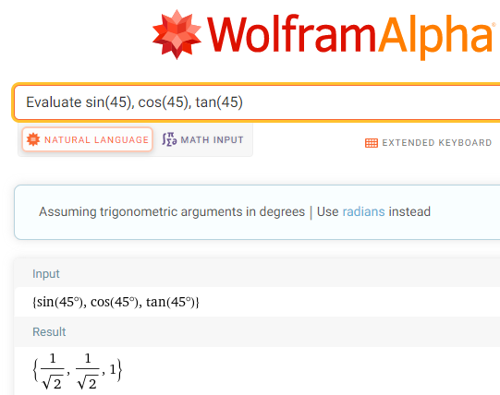

We conclude that , , and .

W|A also provides us with decimal approximations to these ratios.

, , and

Notice that these are the same values we got in Example 2.

Find

Example (4)

To compute these ratios, enter Evaluate sin(30), sin(60), sin(90) into the entry field.

Separate the entries with commas. W|A does not see spaces.

WolframAlpha tells you what it thinks you entered, then tells you its answers.

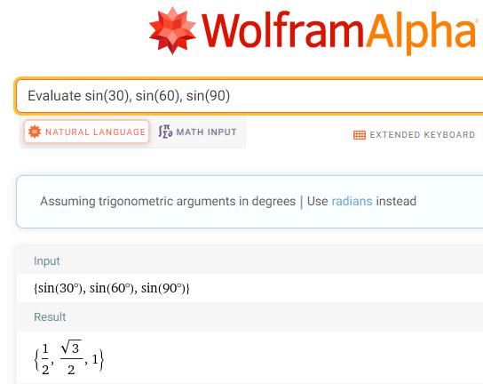

We conclude that and.

W|A also provides us with decimal approximations to these ratios.

and.

### 5.1 Try these

1. Find , cos, and tan for each triangle. Write your answers as decimal numbers rounded to 4 places.

|  |  |  |
| --- | --- | --- |
| a) | b) | c) |
| This image shows a right triangle where the hypotenuse is square root of 2, the adjacent side is 1, and the opposite side is 1. There is an angle of 45 degrees between both the adjacent and hypotenuse sides and the hypotenuse and opposite sides. | This image shows a right triangle where the hypotenuse is 5, the adjacent side is 4, and the opposite side is 3. There is the angle theta between the adjacent and hypotenuse sides. | This image shows a right triangle where the hypotenuse is 3, the adjacent side is square root of 5, and the opposite side is 2. There is the angle theta between the hypotenuse and opposite sides. |
| d) | e) |  |
| This image shows a right triangle where the hypotenuse is the square root of 5, the adjacent side is 1, and the opposite side is 2. There is the angle theta between  the adjacent and hypotenuse sides. | This image shows a right triangle where the hypotenuse is 17, the adjacent side is 8, and the opposite side is 15. There is the angle theta between the adjacent and hypotenuse sides. |  |

1. Find each value. Write your answers as decimal numbers rounded to 4 places.

a) , cos, tan

b) , cos

c) , cos, tan

d) , cos

e) , cos

## 5.2 Circular Trigonometry

### The Sine Function on the Unit Circle

In computer games, objects typically move up-and-down and left-to-right. These movements can be produced using the sine and cosine functions.

Draw a circle with radius 1 unit and on its circumference, place a point, let’s call it .

The circle centered at the origin with radius 1 is called the unit-circle.

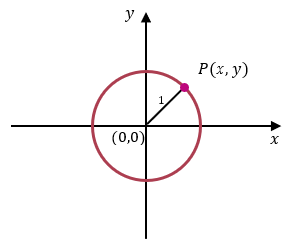

From our presentation of the sine and cosine function using right triangles, we can see that

That is, .

This tells us that the sine of the angle determines the vertical distance of the point from the horizontal axis.

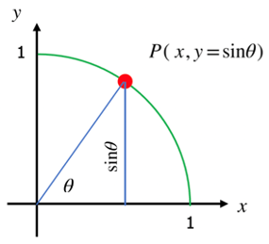

### The Cosine Function on the Unit Circle

To define cosine function, place a point on the circumference of unit-circle.

Once again, from our presentation of the cosine functions using right triangles, we can see that

That is, .

This tells us that the cosine of the angle determines the horizontal distance of the point from the vertical axis.

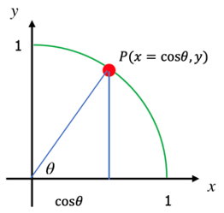

### The Sine and Cosine Functions on any Circle

We can extend this idea by making the radius of the circle units rather than just 1 unit.

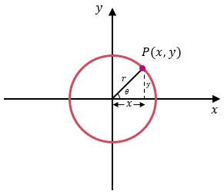

Using the same reasoning we just used with the unit circle, we see that

which, again, tells us that the sine of the angle determines the vertical distance of the point from the horizontal axis and that the cosine of the angle determines the horizontal distance of the point from the vertical axis.

If represents an object, that object’s height off the ground (the horizontal axis) is given by , and that object’s horizontal distance from some reference point is given by . The height of the object is controlled by some number times , and its horizontal distance is controlled by some number times .

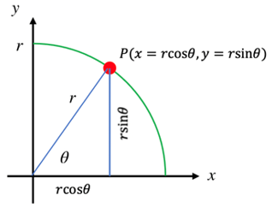

An object lies on the circumference of a unit circle. Find its coordinates if the line segment from the origin to the object makes angle of 30° with the horizontal.

Example (1)

|  |  |
| --- | --- |
| Because the object is on the circumference of unit circle, we can use  and , with , .    The coordinates of the object are (0.8660, 0.5). | This image shows the first quadrant of a circle with a radius of 1. There is a line connecting the center of the circle at (0,0) and the edge of the circle at point P. The line is 30 degrees away from the x-axis. |

An object lies on the circumference of a circle of radius 5 cm. Find its coordinates if the line segment from the origin to the object makes angle of 40° with the horizontal.

Example (2)

|  |  |
| --- | --- |
| Because the object is on the circumference of circle of radius 5 cm, we can use  and , with , .    The coordinates of the object are (3.8302, 3.2139). | This image shows the first quadrant of a circle with a radius of 5. There is a line connecting the center of the circle at (0,0) and the edge of the circle at point P. The line is 40 degrees away from the x-axis. |

The coordinates of an object are (2.1, 3.6373). Find its distance from the origin.

Example (3)

We can use the Pythagorean Theorem, , where is the hypotenuse, the radius of the circle in our case.

We conclude that the object is about 4.2 cm from the origin.

### 5.2 Try these

1. An object lies on the circumference of a unit circle. Find its coordinates if the line segment from the origin to the object makes angle of 45° with the horizontal.
2. An object lies on the circumference of a unit circle. Find its coordinates if the line segment from the origin to the object makes angle of 5° with the horizontal.
3. An object lies on the circumference of a circle of radius 25 cm. Find its coordinates if the line segment from the origin to the object makes angle of 75° with the horizontal.
4. An object lies on the circumference of a circle of radius 10 feet. Find its coordinates if the line segment from the origin to the object makes angle of 135° with the horizontal.
5. How high above the ground is an object that makes an angle of 60° with a 4-foot-tall observer’s eyes and is 35 feet away from that observer’s eyes? Round to two decimals place.

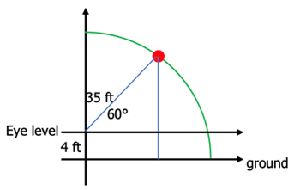

1. The coordinates of an object are (5.682, 2.0521). Find its distance from the origin if it makes an angle of 60° with the horizontal.

## 5.3 Graphs of the Sine Function

### Discrete Graph of the Sine Function from 0° to 90°

The graph of the sine function gives a visual illustration of how it determines the height of an object from a horizontal axis.

Imagine an object moving counterclockwise along the circumference of the unit circle. Start the object’s motion at the point (1,0), then measure its height from the horizontal axis as its angle from origin increases from 0° to 90°.

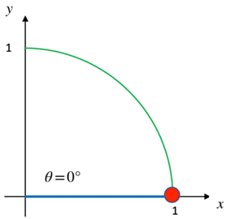

Height of object from horizontal

= = 0 units

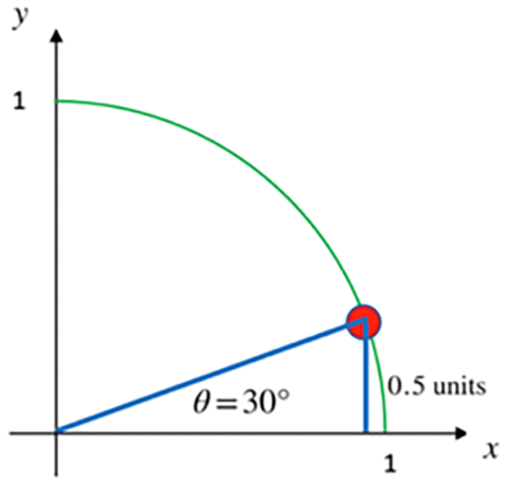

Height of object from horizontal

= = 0.5 units

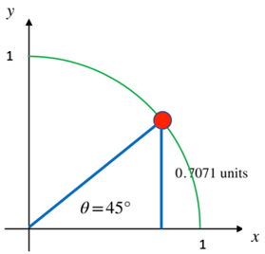

Height of object from horizontal

= ≈ 0.7071 units

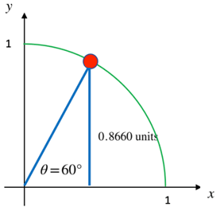

Height of object from horizontal

= ≈ 0.8660 units

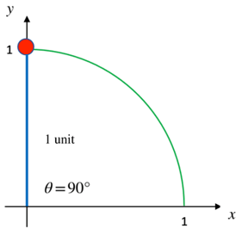

Height of object from horizontal

= ≈ 1 unit

### Graphs of the Heights

If the angle is between 0° and 90°, the graph of the heights looks like this

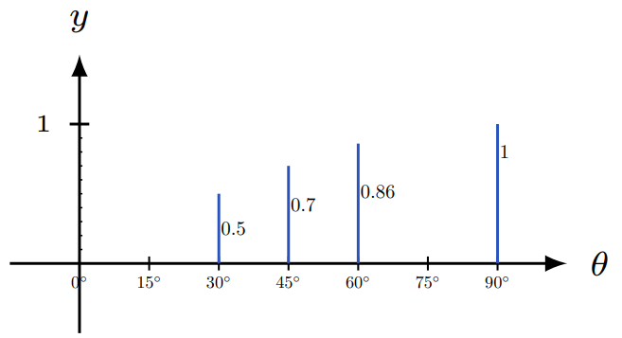

We can see that from 0° to 90°, as the angle from the observer to the object increases, the height of the object from the horizontal increases. That is, *the object moves vertically upward.*

If the angle goes past 90°, say all the way to 180°, the graph of the heights looks like this

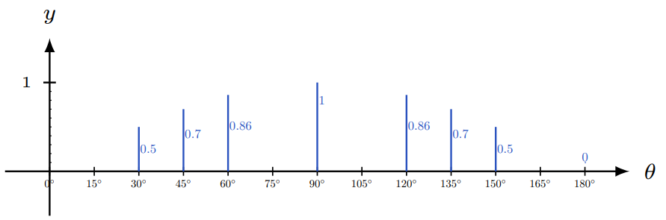

*The object moves vertically upward, then vertically downward.*

### The Continuous Sine Curve from 0° to 90°

If we plotted all the heights for all the infinitely many angles between 0° and 90°, we would get this continuous graph

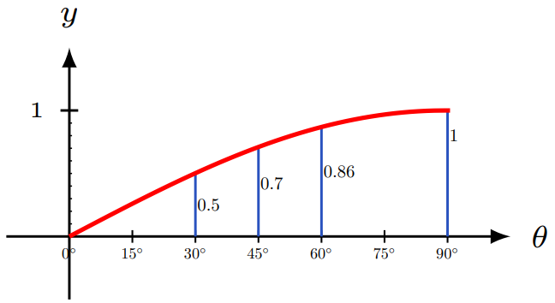

for

### The Continuous Sine Curve from 0° to 180°

If we plotted all the heights for all the angles between 0° and 180°, we would get the continuous graph below

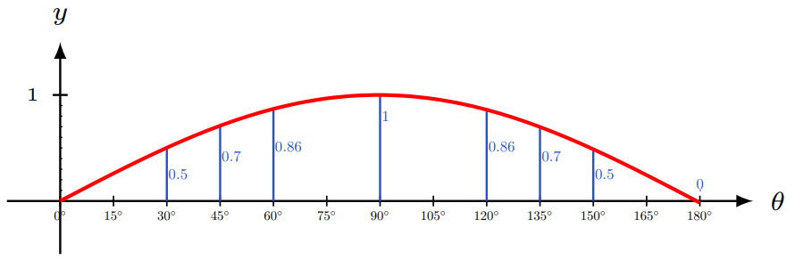

for

### The Continuous Sine Curve from 0° to 360°

If we were to let the object travel all the way around the circle, we get the graph of the sine curve from 0° to 360°. You can see that when the angle is between 180° and 360°, the object is below the horizontal and may not be visible to an observer.

This image shows a graph with all of the heights plotted from the angles between zero degrees and 360 degrees. From zero degrees to 180 degrees the heights are above the x-axis and from 180 degrees to 360 degrees the heights are below the x-axis. There is a red curved line connecting the end points of the lines. The red line starts at zero and curves upward before coming back down to cross the x-axis at 180 degrees. It continues to curve downward and then curves back upward to the x-axis at 360 degrees.
Plotted curve represents the continuous sine curve from 0 to 360 degrees.

for

### The Extended Sine Curve

If we were to let the object keep travelling around the circle, we would see that the height of the curve just oscillates between –1 and 1.

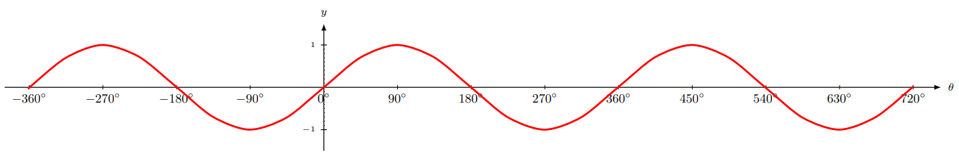

It may now be visually apparent that

The sine function controls the vertical distance of an object above or below the horizontal.

##### What to See

The graph shows how an object’s vertical distance from the horizontal changes as the angle of view increases. As the angle of view increases, the vertical distance from the horizontal increases and decreases.

##### What Not to See

The graph does not show how an object moves horizontally as the angle of view increases. The object is not moving up and down horizontally along the curve as time goes by. The horizontal axis is the angle of view, not time.

### 5.3 Try these

1. An object moves along the circumference of a unit circle. Find its height from the horizontal if the angle it makes from the origin is
   1. 225°
   2. 270°
   3. 315°
   4. 360°
2. An object moves along the circumference of a unit circle. Find its height from the horizontal if the angle it makes from the origin is
3. 390°
4. 405°
5. 420°
6. 450°
7. Determine if each statement is true or false.
8. Height at 87° > height at 78°
9. Height at 155° > height at 145°
10. Height at 30° height at 150°
11. Height at 90° height at 270°
12. Keeping in mind that the sine function determines vertical distance, and the cosine function determines horizontal distance, determine if each statement is true or false. The observer is at the origin.
13. Vertical height at 87° > horizontal distance at 87°
14. Vertical height at 155° > horizontal distance at 55°
15. Vertical height at 20° < horizontal distance at 20°
16. Vertical height at 135° = horizontal distance at 315°

## 5.4 Graphs of the Cosine Function

### Discrete Graph of the Cosine Function from 0° to 360°

Just as the sine function determines the vertical distance of an object from an observer, the cosine function determines the horizontal distance of an object from that observer.

Here is table of values for the cosine function for angles between 0° and 360° followed by a graph of the cosine function for all angles from 0° to 360°.

|  |  |
| --- | --- |
| Angle | Cosine  (Horizontal Distance from Observer) |
| 0° | 1 |
| 45° | 0.7071 |
| 90° | 0 |
| 135° | –0.7071 |
| 180° | –1 |
| 225° | –0.7071 |
| 270° | 0 |
| 315° | 0.7071 |
| 360° | 1 |

The positive cosine values indicate that the object is to the front of the observer whereas the negative values indicate that the object is to the back of the observer.

For example, at an angle of 45° from the observer’s eye, the object is 0.7071 units in front of the observer.

At an angle of 135° from the observer’s eye, the object is 0.7071 units behind the observer.

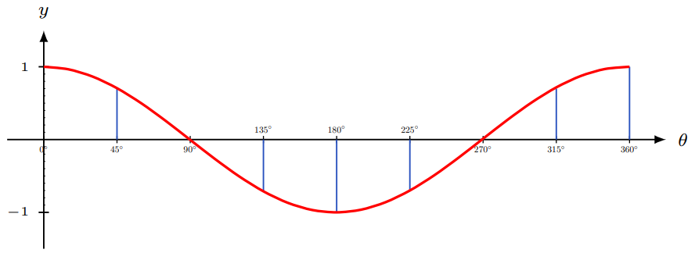

If you think that this graph looks like the graph of the sine function, but shifted to the left by 90°, you would be right.

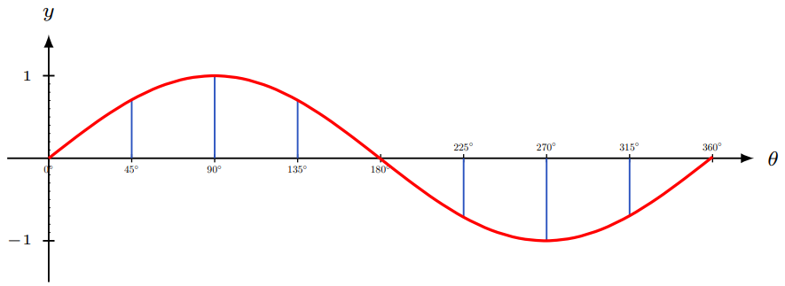

### The Extended Cosine Curve

Just as the sine curve does, the heights of the cosine curve oscillate between –1 and 1.

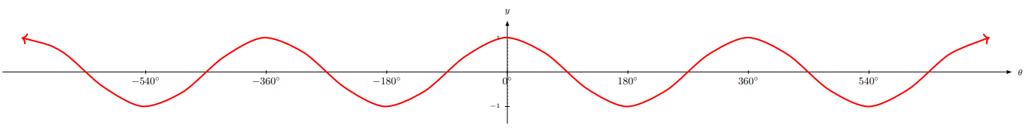

The graph of the cosine function gives a visual illustration of how it determines the horizontal distance of an object from a vertical axis.

It may now be visually apparent that

The cosine function determines the horizontal distance of an object to the left or right of an observer.

##### What to See

The graph shows how an object’s horizontal distance from the observer changes as the angle of view increases. As the angle of view increases, the horizontal distance from the vertical increases (moves away from the observer) and decreases (moves toward the observer).

##### What Not to See

The graph does not show how an object moves vertically as angle of view increases. The object is not moving along the curve.

### 5.4 Try these

1. An object moves along the circumference of a unit circle. Find its horizontal distance from an observer if the angle it makes from observer’s eye is

a. 225°

b. 270°

c. 315°

d. 360°

1. An object moves along the circumference of a unit circle. Find its horizontal distance from an observer if the angle it makes from observer’s eye is

a. 390°

b. 405°

c. 420°

d. 450°

1. Determine if each statement is true or false.
2. Horizontal distance at 87° > Horizontal distance at 78°
3. Horizontal distance at 45° > Horizontal distance at 145°
4. Horizontal distance at 30° Horizontal distance at 150°
5. Horizontal distance at 90° = Horizontal distance at 270°

## 5.5 Amplitude and Period of the Sine and Cosine Functions

### Amplitude

We have seen how the graphs of both the sine function, and the cosine function , oscillate between and . That is, the heights oscillate between –1 and 1.

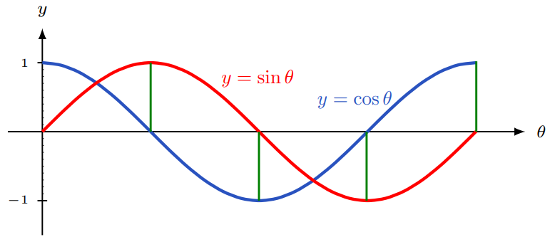

The height from the horizontal axis to the peak (or through) of a sine or cosine function is called

the **amplitude** of the function. Each of the curves and has amplitude 1.

If we were to multiply the sine function by , getting , each of the sine values would be multiplied by 3, making each value 3 times what it was. Each height would be tripled. The amplitude of is 3.

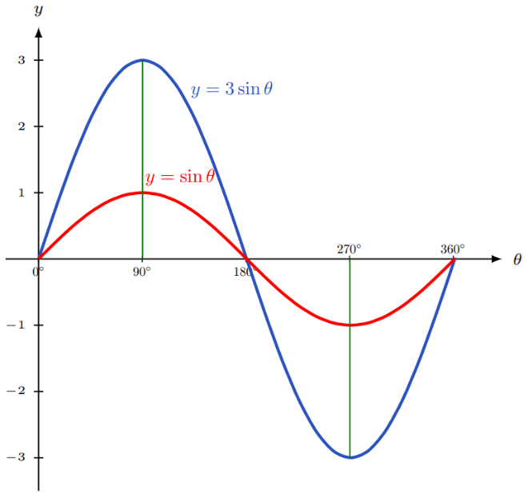

If we were to multiply the cosine function by , getting ,  
each of the cosine values would be multiplied by 1/3 making each value 1/3 of what it was. Each height of would be 1/3 of what it was.  
The amplitude of is 1/3.

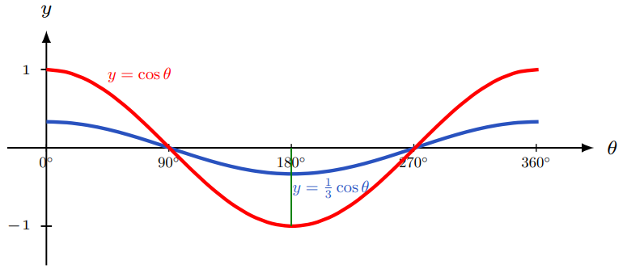

### THE AMPLITUDE OF AND

Suppose represents a positive number. Then the **amplitude** of both and is and it represents height from the horizontal axis to the peak of the curve.

Examples

The amplitude of is 5/8. This means that the peak of the curve is 5/8 of a unit above the horizontal axis.

The amplitude of is 3. This means that the peak of the curve is 3 units above the horizontal axis.

### Period

Both the sine function and cosine function, and go through exactly one cycle from 0° to 360°. The **period** of the sine function and cosine functions, and is the “time” required for one complete cycle.

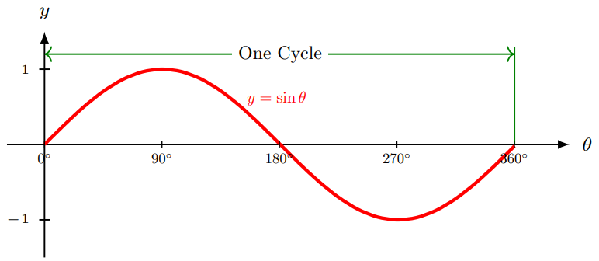

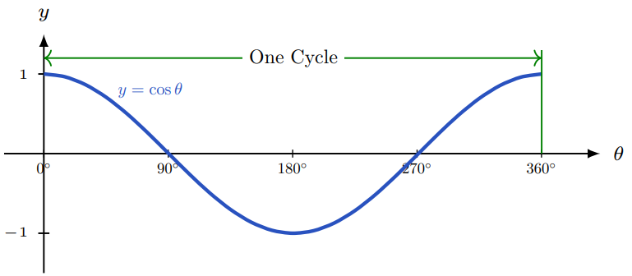

An interesting thing happens to the curves and when the angle is multiplied by some positive number, If the number is greater than 1, the number of cycles on 0° to 360° increases for both and . That is, the peaks of the curve are closer together, meaning their periods decrease. If the number is strictly between 0 and 1, the peaks of the curve are farther apart, meaning their periods increase.

### THE PERIOD OF AND

Suppose represents a positive number. Then the **period** of both and is As B gets bigger, gets smaller and the period increases.

If we were to multiply the angle in the sine function by , getting , each of the angle’s values would be multiplied by 3 making each value 3 times what it was. Each angle would be tripled and there would be 3 cycles in the interval 0° to 360°.

The period of is . The period of is smaller than that of .

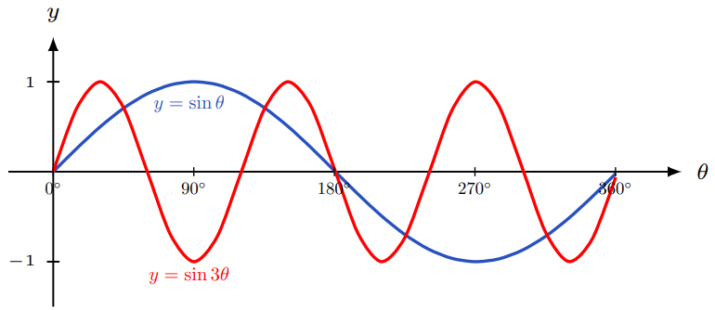

If we were to multiply the angle in the sine function by , getting Each of the angle’s values would be multiplied by 1/3 making each value 1/3 what it was and there would be only 1/3 of a cycle in the interval 0° to 360°.

The period of is = . The period of is greater than that of

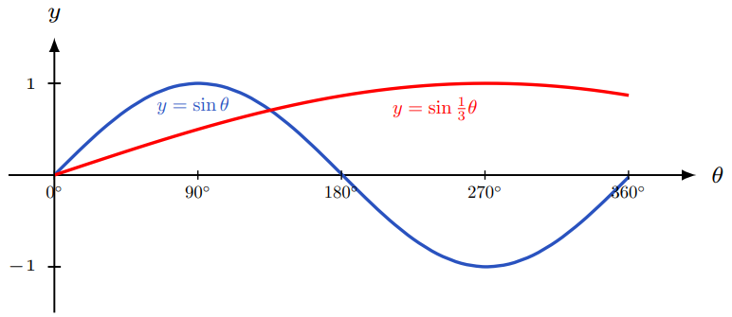

### Using Technology

We can use technology to help us construct the graph of a sine or cosine function.

Go to www.wolframalpha.com.

Plot two complete cycles of from 0° to 360°.

Example (1)

Type plot y = 6sin2x, x = 0..360 degrees in the entry field.

WolframAlpha tells you what it thinks you entered, then produces the graph.

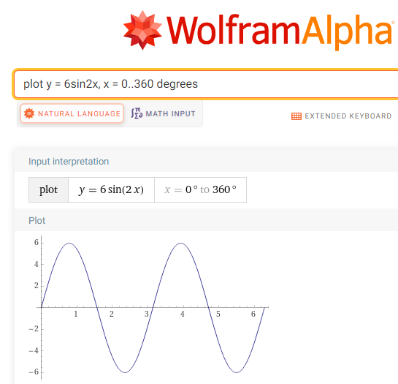

You can see that WolframAlpha has plotted two complete cycles from 0° to 360° with amplitude 6.

Find the period of .

Example (2)

We just need to evaluate with .

The period of is

The graph of helps us visualize this 45° period. You can see that the peaks differ by 45°.

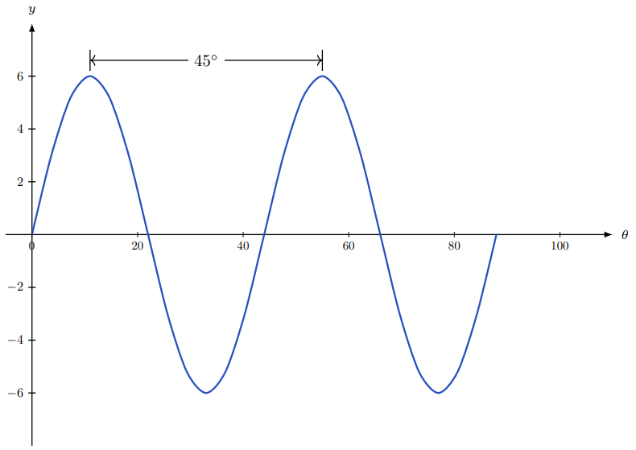

### 5.5 Try these

1. Write the equation of each graph.
2. 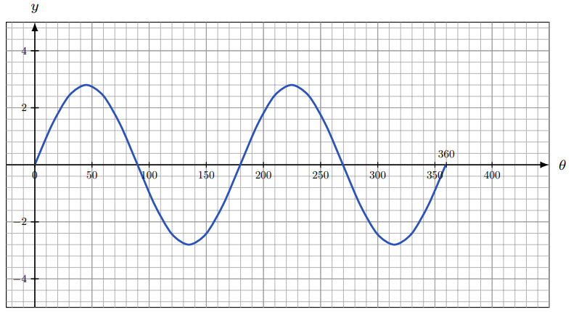
3. 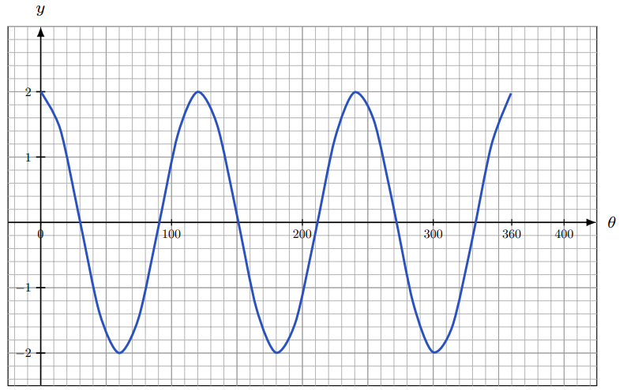
4. 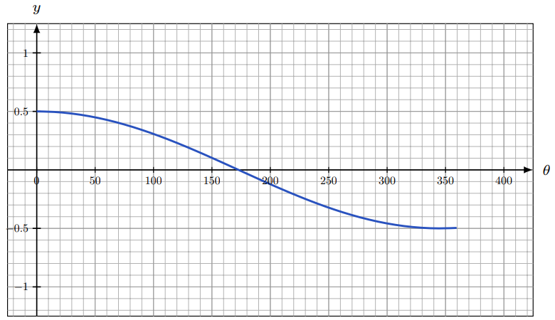
5. How many complete cycles are there in the graph of from 0° to 360°? What is the period and amplitude of this function?
6. How many complete cycles are there in the graph of from 0° to 360°? What is the period and amplitude of this function?
7. Write the equation of a sine curve that has amplitude 15 and period 50°. You need to specify both in . Keep in mind that the period of this function is .
8. Write the equation of a cosine curve that has amplitude 100 and period 12°. You need to specify both in . Keep in mind that the period of this function is .
9. Write the equation of a cosine function that has amplitude 3 and makes two complete cycles from 0° to 180°.
10. Write the equation of a sine function that has amplitude 4 and makes three complete cycles from 0° to 90°.